Assignment 3: Operators and Expressions

Name: Harshal Atre Balkrishna

Roll NO. : A-76

1.Write a program to swap two numbers with and without using a temporary variable.

Answer:

Source code:

WITH TEMP VARIABLE:

#include <stdio.h>

int main(){

int a,b,temp;

printf("Enter a= " );

scanf("%d",&a);

printf("Enter b= " );

scanf("%d",&b);

temp=a;

a=b;

b=temp;

printf("a= %d ",a);

printf("b= %d",b);

}

WITHOUT TEMP VARIABLE:

#include <stdio.h>

int main(){

int a,b;

printf("Enter a= " );

scanf("%d",&a);

printf("Enter b= " );

scanf("%d",&b);

a=a+b;

b=a-b;

a=a-b;

printf("a= %d ",a);

printf("b= %d\n",b);

}

OUTPUT:

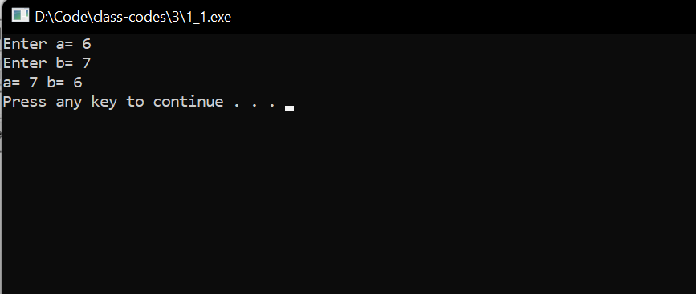

2.Write a c program that reads two numbers and performs their division. If the division is not possible, then an error message, "Division not possible" is displayed

Answer:

Source code:

#include <stdio.h>

int main(){

int a,b;

printf("Enter a = " );

scanf("%d",&a);

printf("Enter b = " );

scanf("%d",&b);

if(a%b==0){

printf("The division is possible");

}

else{

printf("The division is not possible\n");

}

}

OUTPUT:

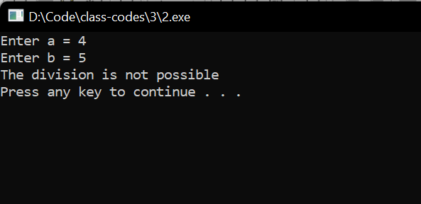

3.Write a c program to input the value of days and convert it into years, weeks and days.

Answer:

Source code:

#include <stdio.h>

#include <stdlib.h>

int main(){

int years,months,days,week;

printf("Enter the days ");

scanf("%d",&days);

years=days/365;

week=(days%365)/7;

days=days-(years*365+week*7);

printf("years = %d " ,years);

printf("week = %d " ,week);

printf("days = %d\n " ,days);

system("pause");

}

OUTPUT:

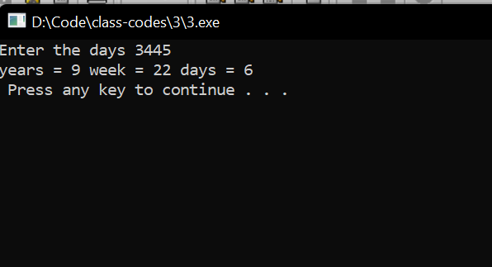

4.Write a c program to input the distance travelled by a car and the fuel consumed. Next compute the mileage of the car and display.

Answer:

Source code:

#include <stdio.h>

#include <stdlib.h>

int main(){

float distance,fuel,mileage;

printf("Enter the Distance Travelled (in km) ");

scanf("%f",&distance);

printf("Enter the fuel consumed (in liters) ");

scanf("%f",&fuel);

mileage=distance/fuel;

printf("The mileage of the vehicle is %.1f ",mileage);

printf("km per liter\n");

system("pause");

}

OUTPUT:

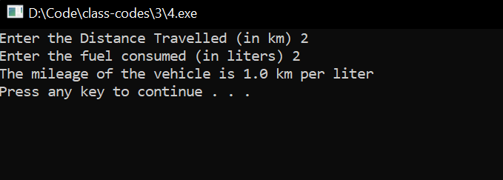:

5.Write a program that takes distance in inches and prints the corresponding value in cms.

(Note that 1 inch = 2.54 cm)

Answer:

Source code:

#include <stdio.h>

#include <stdlib.h>

int main(){

int inches;

printf("Enter the distance in inches ");

scanf("%d",&inches);

float centimeters=inches*2.54;

printf("The Distance in centimeters is %.2f",centimeters);

printf(" cm \n");

system("pause");

}

OUTPUT:

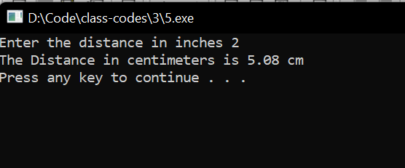

6.The cost of one type of mobile service is Rs. 250 plus Rs. 1.25 for each call made overand above 100 calls. Write a _program to read customer codes and calls made and print the bill for each customer.

Answer:

Source code:

#include <stdio.h>

#include <stdlib.h>

int main(){

int cost,bill,calls;

printf("Enter the No. of calls made ");

scanf("%d",&calls);

cost=250;

if(calls>=100){

bill=cost+(1.25*(calls-99));

}

else{

bill=cost;

}

printf("The bill is %d ",bill);

printf("Rs\n");

system("pause");

}

OUTPUT:

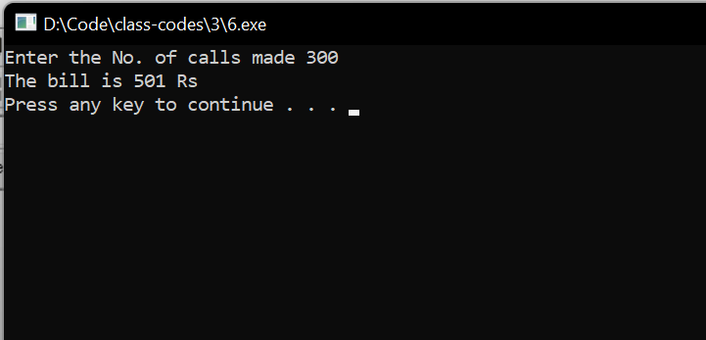

7.Write a c program to shift the given data by two bits to the left.

Answer:

Source code:

#include <stdio.h>

#include <stdlib.h>

int main(){

int a;

printf("Enter the number to be shifted ");

scanf("%d",&a);

a=a<<2;

printf("The number after shiifting bitwise 2 space left %d\n",a);

system("pause");

}

OUTPUT:

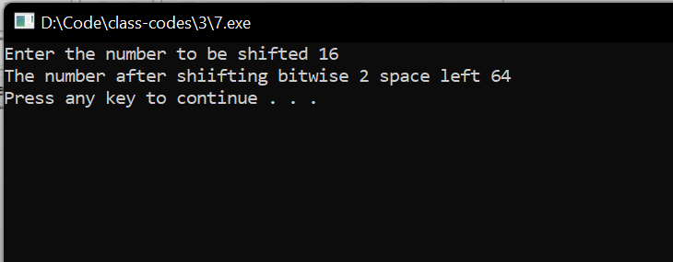

8.Write a program to input the value of 4 variables a, b, c and d, Compute the resultantvalue of the following expressions:

a. (a+b) * (c /d)

b. (a + b) *c/d

c. a+(b*c) / d

Answer:

Source code:

a.

#include <stdio.h>

#include <stdlib.h>

int main(){

int a,b,c,d,ans;

printf("a= ");

scanf("%d",&a);

printf("b= ");

scanf("%d",&b);

printf("c= ");

scanf("%d",&c);

printf("d= ");

scanf("%d",&d);

ans=(a+b)*(c/d);

printf("Answer is %d\n",ans);

system("pause");

}

b.

#include <stdio.h>

#include <stdlib.h>

int main(){

int a,b,c,d,ans;

printf("a = ");

scanf("%d",&a);

printf("b = ");

scanf("%d",&b);

printf("c = ");

scanf("%d",&c);

printf("d = ");

scanf("%d",&d);

ans=(a+b)*c/d;

printf("Answer is %d\n",ans);

system("pause");

}

c.

#include <stdio.h>

#include <stdlib.h>

int main(){

int a,b,c,d,ans;

printf("a = ");

scanf("%d",&a);

printf("b = ");

scanf("%d",&b);

printf("c = ");

scanf("%d",&c);

printf("d = ");

scanf("%d",&d);

ans=a+(b*c)/d;

printf("Answer is %d\n",ans);

system("pause");

}

OUTPUT:

a.

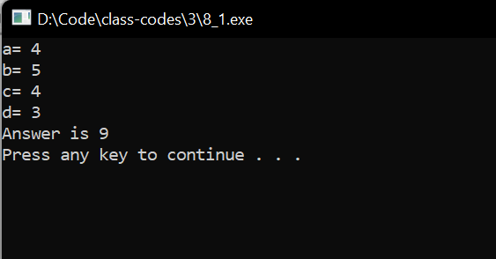

b.

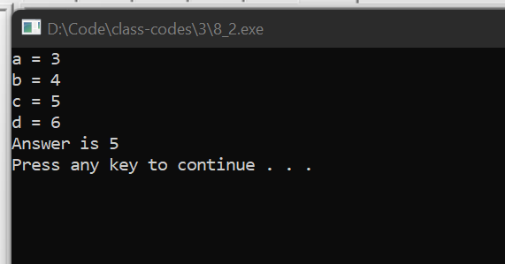

c.

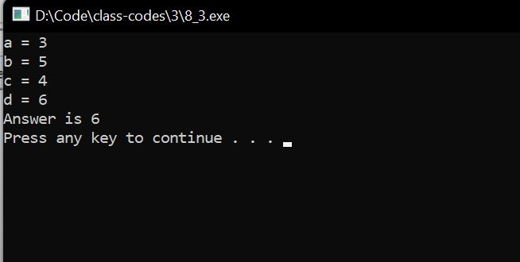

9.Given three values, write a program to read three values from the keyboard and print out

the largest of them without using if statement.

Answer:

Source code:

#include <stdio.h>

#include <stdlib.h>

int main(){

int a,b,c;

printf("Enter a = ");

scanf("%d",&a);

printf("Enter b = ");

scanf("%d",&b);

printf("Enter c = ");

scanf("%d",&c);

(a>b)?(a>c)?printf("a is greater\n"):printf("c is greater\n"):(b>c)?printf("b is greater\n"):printf("c is greater\n");

system("pause");

}

OUTPUT:

